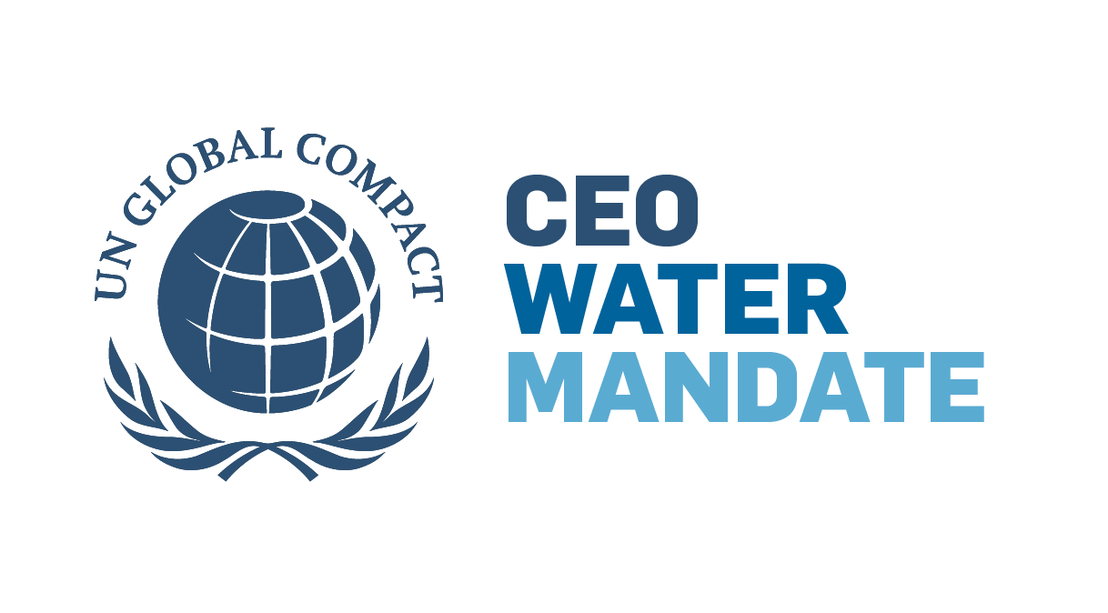

**Sign the Water Resilience** **Pledge**

**OUR VISION: GLOBAL WATER RESILIENCE**

The business sector is in a unique position to help lead the way toward water resilience because of its reach and the resources it can leverage to accelerate progress. We must expand the scale and scope of our efforts to address the magnitude of the mounting water crisis. With this pledge, we plan to catalyze a movement to achieve our shared vision: freshwater basins able to consistently supply what’s needed for communities, businesses and the environment on which we all depend.

The path toward a water resilient future must be meaningful and measurable.

**OUR PLEDGE**

In signing this pledge, I confirm that my company will achieve the following by 2050, through both individual and collective actions:

* **Net positive water impact**: Achieve a measurable and net positive impact in water-stressed basins on availability, quality and accessibility through industry-leading water operations and basin initiatives
* **Water-resilient value chain**: Develop, implement, and enable strategies to support leading impact-based water resilience practices across the global value chain
* **Global leadership**: Raise the global ambition of water resilience through public and corporate outreach

And we will reach the half-way mark by 2030.

**Pledge signatories commit to achieving interim targets toward the 2050 goals as outlined in the pledge through:**

* Active support of existing and new watershed coalitions and partnerships
* Enabling new tools and technology
* Spreading shared water use and reporting standards for supply chain
* Advocating for smart water management and equitable access policies by government
* Partnering with members and NGOs on water basin investment and access initiatives

**SIGN THE PLEDGE**

Our company pledges to achieve the goals described above by 2050.

Signed,

[SIGNATURE]

[NAME OF SIGNER]

[TITLE OF SIGNER]

On behalf of

[NAME OF C-SUITE REPRESENTATIVE or equivalent]

[TITLE OF C-SUITE REPRESENTATIVE or equivalent]

**JOIN THE WATER RESILIENCE COALITION**

Some pledge signatories choose to deepen their commitment and participation by formally join the CEO Water Mandate’s *Water Resilience Coalition*. In doing so, they work closely with other Coalition members and partners to coordinate and advance strategic, impactful activities in the world’s most water-stressed river basins.

Participation in the UN Global Compact and CEO Water Mandate are both prerequisites for joining the Coalition.

As part of their commitment to supporting the work of the Coalition, companies contribute anywhere from $10,000 – $100,000 annually depending on their revenue and level of engagement (i.e., Leadership Committee or regular Coalition member). This contribution is separate from [membership dues](https://www.unglobalcompact.org/participation/tiers) for participation in the UN Global Compact.

Our company is interested in becoming a member of the *Water Resilience Coalition*

**CONTACT INFORMATION**

Please indicate below who our main point of contact should be for your organization. We will contact this person about communications opportunities, tracking progress, working groups they are encouraged to join, policy advocacy efforts, and other collective actions.

[CONTACT NAME]

[CONTACT COMPANY]

[CONTACT TITLE]

[CONTACT PHONE NUMBER]

[CONTACT EMAIL ADDRESS]

**SUBMITTING YOUR PLEDGE**

Thank you for your interest in signing the *Water Resilience Pledge*. Once you submit this signed form via DocuSign, we will conduct brief due diligence and then add you to a list of companies that have signed the pledge on the *Water Resilience Coalition* website.